# Legal forms of business organisations

These business organisation are used for for understanding the business law. If a person wants to establish or create his own enterprise it’s very useful to know the different legal forms of business organisations. It’s very crucial to know every rights and details. Without any know – how it’s very hard to establish a company because there are so many cases of the law etc.

This grafik will show you the legal forms of business organisations:



In this grafik of business organisations you are able to see which forms you can create and it’s often very important for the persons who wants to do this.

But before a person wants to establish an enterprise he has to ask some questions to himself:

* Can I run the business alone ?
* If I cannot, what do I need a partner for ? Do I need anyone how has the know how?
* What are the partners rights and duties? Should every partner have the same rights and responsibility ?
* Is someone prepared to assume unlimited liability ? Will somebody fully liable for the debts and obligations of the enterprise with his own money?
* Am I prepared to bear high costs for setting up a business?
* What future profits can I except?
* Wich legal formof business organisation offers the most substantial tay advantage?

These are very much questions but if you are able to match these one then you can build up an enterprise. A legal form of business organisations can be changed evertime like from an private limited company (Ltd.) to an sole trader.

## Difference between partnerships and capital companies

Businessmen who have the know - how to run an enterprise alone they want a bigger enterprise. The type of the business organisation depends on the size of the enterprise, its capital requirements, and tax considerations and whether or not the individuals involved are prepared to assume unlimited personal liability. We can decide between non – incorporated business organisations and incorporated business organisation.

The major difference between partnerships and companies is that they are subject to different rates of taxation.

### Partnership

A partnership is a business organization formed and owned by two or more businesspeople. One of them has to assume unlimited personal liability for the enterprise’s business activities.

### Companies

Companies are ideal for people how want to invest capital in exchange for a share in the profit. Especially limited companies can raise larger amounts of funds than sole proprietorships an partnerships by issuing shares to the general public.

The shares can be transferred more easily than stakes in partnerships.

An example for an incorporated bussiness organisations is a private limited company (Ldt.) or a public limited company (PLC).

## Non – incorporated business organizations

In this section there are also more dividers:



### Sole trader or sole proprietorship

Nearly every entrepreneur starts up with a sole proprietorship because it’s the cheapest and easiest business organisations at the beginning.

* Advantages:
  + Very low costs to set up a business
  + Making his own decisions
    - Price , costumers
  + More flexibility
    - Decisions can be made fast
  + Simply bookkeeping
    - No P&L and Balance sheet
    - Limit till 700.000 € of revenues
* Disadvantages:
  + Less money
  + Low creditworthiness
  + They mostly give up because they work alone
  + Is responsible for his mistakes
    - Unlimited personal liability

### Partnerships

There are two different partnerships

* General Partnership
* Limited Partnership

A partnership is not a legal entity and this means that it has no legal existence separate from that of its members. The partners own the business assets and are liable for it.

#### General Partnership

The general Partnership is a so called “Offene Gesellschaft” -> OG. This is a business idea for more partners. All partners have the same shares but also the same risks. The partners:

* Share the profit
* Decisions – making process
* Usually work business together
* Are liable for it

The most important thing in a general partnership is the mutual trust. Should be better than in a family. Ever partner is allowed to sign contracts also alone without the other partners. If a partner makes a decision and this decisions leads to insolvency then there is a joint and several liability. The debtor is allowed to collect money from the other partners. Every partner is liable with his own money.

#### Limited Partnership

The limited partnership is a so called “Kommandit Gesellschaft” -> KG.

There a two forms of partners:

* Limited Partner
* General Partner

A limited partner is only liable for this money with which he is integrated in the company. The private property is not attacked but he is able to see the accounting.

A general partner is liable for the assets. They also make decisions and present the company.

## Incorporated business organizations

In this section there are also more dividers:

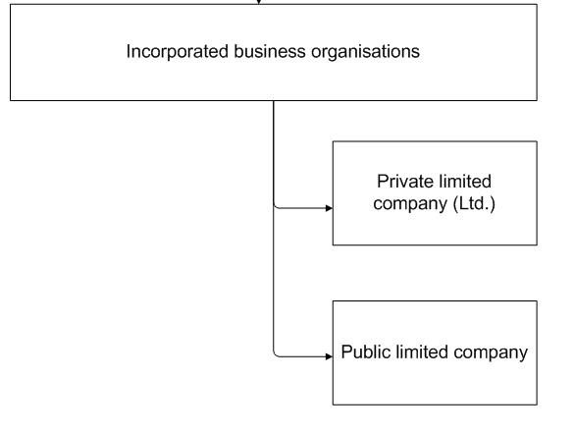

### Private limited company

The private limited company is a so called “Gesellschaft mit beschränkter Haftung”. A private limited company is a legal entity.

Advantage:

* The company’s members have limited liability
* Shares in the company can be transferred easily
* Nobody is liable with his own money
* It’s also possible that one man set up a business

Disadvantages: (law in Austria)

* You need 35.000€ to set up the business
  + 17.500€ cash at hand
  + 17.500€ Utensils (Cars, Houses…)
* After this you need 4.000€ again
  + Notary
  + Judgment
  + Directory
* Double – entry bookkeeping

The private limited company will be present of a managing director. He hasn’t rights in the company but he is allowed to sign contracts

An important thing before you set up a private limited company is that you have cash at hand and don’t take it from the bank like a loan. Because the company needs security and that means your own money. So if you haven’t that much money it is better to stay with a sole proprietorship and don’t make a private limited company.

### Public limited company

Is a so called “Aktiengesellschaft” -> AG. The short name in English of a public limited company is PLC. If the company is successful and it wants to grow further then the best thing to do is to enter new markets or to become international. But to perform this action the company needs very much money. Here there are two different paths:

1. To get money from the bank as a loan but the major drawback is that the bank accept only a limited risk. That means that the bank wants the much more money back regardless of whether or not the business makes a profit.
2. To get the money from other institutions or individual partners which invest in the money.The best things is to invite as many people as possible to participate the business by investing small amounts of money. So there is no money which you have to pay back. The only thing you have to do is to pour the profit out to the investors.

To set up a public limited company you need 70.000€.

The nominal capital or a certain amount of share has to be authorized and split up into any desired number of equal parts. So the investors are able to buy such a part. These parts are called shares. If an Investor buys a share he is a so called shareholder. With a small amount of money the investor is a member of the business.

Calculation of the shares: Example

The capital amounts of 70.000€. The minimal amount is 1€ for 1 Share (70.000€ : 70.000 = 1€). But the so called “Issue price” have to be higher like 2€.

Issue Price -> 2€

Minus Nominal Par -> 1€

--------------------------------------------------------------------

Agio -> 1€

The Agio is the calculation Issue Price minus Nominal Par. The Investor of the share profits from the trend of the agio. The higher the Agio the higher the valence of the share.

To find an investor for the company:

* the issue price of the share must not to high
* the issue price of the share must not to low

The shareholder has even a number of rights. There is including the right to vote. Let’s give an example: If an investor has fifty shares and so he has fifty votes.

Institution in a public limited company:

* Annual general meeting of the shareholders

At this meeting the shareholders elect the so called **supervisory board**. The supervisory board will appoint the so called **managing board**.

* + Supervisory board is here to supervise the managing board.
  + The managing board is allowed to sign contracts and represents the company on the international market.

This graphic will show you the election again:

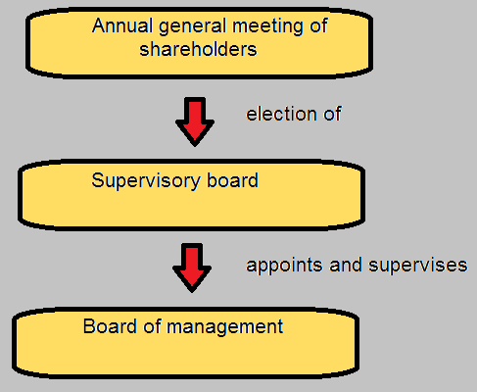

* Right to vote -> 1 share = 1 vote#

Another important point for the company is the **return on investment.** There are two points for return on investment:

* Dividend: The company pours out the profit to the shareholders
* Rising share price: If the company become more and more popular and the company have a great demand on their shares then the issue price will increase.

If you want the full control of the public limited company you need 51 percent of the shares. That means 50 percent plus 1.

If the public limited company is in bankruptcy the value of the share is like a piece of paper.

This legal business for m is only for larger enterprises.

# Additional legal forms of business organisations

## Undisclosed partnership

* Advantages for the undisclosed partner:
  + He shares profits without having to work in the business
  + He is not liable with his private property
* Disadvantages for the undisclosed partner:
  + He has no say in the enterprise
  + This form of investment may be quite risk
* Advantage for the company:
  + No fixed interest payments and loan redemption
* Disadvantages for the enterprise:
  + The profit share agreed upon may be substantial

## Civil – law partnership

Connection for a project(LKH – Neu). In most cases civil law partnership exists only for the duration of a given project.

## Limited commercial partnership

This is a private limited company as general partner in a limited partnership.

# Business Combinations

## Group of companies

If a company controls only one other firm the term company “Konzern” can be applied.

The controlling company is named holding or parent company. Under the holding company are subsidiaries - > Tochterfirma

The holding company appoints the subsidiaries management and devices how to allocate it’s profit, laws,… . Holding companies often lose the control over their subsidiaries.

## Cartel

It refers to an association of several legally independent enterprises for th8e purpose of restricting competition and dividing the market among the members.

Very much countries have a law against it.