### Public limited company

Is a so called “Aktiengesellschaft” -> AG. The short name in English of a **public limited company is PLC**. If the company, like the private limited company, is successful and it wants to grow further then the best thing to do is to enter new markets or to become international.

But to perform this action the company needs very much money or funds.

Here there are two different paths to get money:

1. To get money from the bank as a loan but the major drawback is that the bank accepts only a limited risk. That means that the bank wants the much more money back regardless of whether or not the business makes a profit.
2. To get the money from other institutions or individual partners which invest in the company. The best thing is to invite as many people as possible to participate the business by investing small amounts of money. So there is no money which you have to pay back. The only thing you have to do is to pour the profit out to the investors.

The PLC is the legal business form that allows you to do so.

**To set up a public limited company you need 70.000€.**

The nominal capital or a certain amount of share has to be authorized and split up into any desired number of equal parts. So the investors are able to buy such a part. **These parts are called shares**. If an Investor buys a share he is a so called **shareholder**. With a small amount of money the investor is a member of the huge business.

Another important point is the **nominal share value**. It’s calculated by dividing the share capital by the number of share issued.

**Calculation of the shares: Example**

The capital amounts of 70.000€. The minimal amount is 1€ for 1 Share (70.000€ : 70.000 = 1€). But the so called “Issue price” have to be higher like 2€.

Issue Price -> 2€

Minus Nominal Par -> 1€

--------------------------------------------------------------------

Agio -> 1€

The **Agio** is the calculation Issue Price minus Nominal Par. The Investor of the share profits from the trend of the agio. The higher the Agio the higher the valence of the share.

**To find an investor for the company:**

* the issue price of the share must not to high
  + the company runs the risk to find no enough buyers
* the issue price of the share must not to low
  + many buyers are attracted , but the company may fail to seize the opportunity to raise more money

The shareholder has even a number of rights. There is including the right to vote. Let’s give an example: **If an investor has fifty shares and so he has fifty votes.**

**Institution in a public limited company:**

* *Annual general meeting of the shareholders*

At this meeting the shareholders elect the so called **supervisory board**. The supervisory board will appoint the so called **managing board**.

* + Supervisory board is here to supervise the managing board.
  + The managing board is allowed to sign contracts and represents the company on the international market.

This graphic will show you the election again:

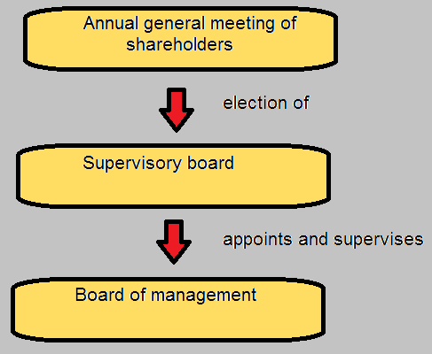

* Right to vote -> 1 share = 1 vote

Another important point for the company is the **return on investment.** There are two points for return on investment:

* Dividend: The company pours out the profit to the shareholders
* Rising share price: If the company become more and more popular and the company have a great demand on their shares then the issue price will increase.

If you want the full control of the public limited company you need 51 percent of the shares. That means 50 percent plus 1.

If the public limited company is in bankruptcy the value of the share is like a piece of paper.

This legal business for m is only for larger enterprises.

**Advantages for the shareholders:**

* Chance to invest even small amounts in large enterprises
* Right to receive a dividend
  + Share in the profit generated annually
* Possible increase in the value of the shares
* Fairly easy resale of shares

**Disadvantages for shareholders:**

* Share price may decrease in value
  + It may drop to zero if the company goes bankrupt
* Small shareholders assume entrepreneurial risk without having any major influence on company management

**Advantages for the company:**

* Funds are raised without obligation of capital redemption and interest payments

**Disadvantages for the company:**

* High volume and costly administrative work